**pyGC Installation and Operation instructions**

To install the GC deconvolution program, run the ‘mysetup.exe’ application included in the supplemental.

1. A desktop application has been made available via GitHub. Once anaconda is installed to your computer (regardless of operating system), run the following command in the command line:

pip install git+https://github.com/1mikegrn/pyGC

1. Once the pyGC package is installed, it can be activated from the command line via entering the following command:

pyGC-init

1. After calling pyGC-init, a window will appear with a graph pane and several prompts which are available for input. Input Data can be in either a Microsoft Excel (.xlsx) file, a comma-separated .csv file, or a tab-separated .csv file, as a X by 2 array. This file should be formatted using columns (1, 2) for the (x, y) data columns derived from experiment. Text above and below the data will be automatically filtered out by the program. There is no restriction on the number of rows utilized for calculation. Pressing the ‘Import Data’ button subsequently opens a file explorer window to locate the input files.

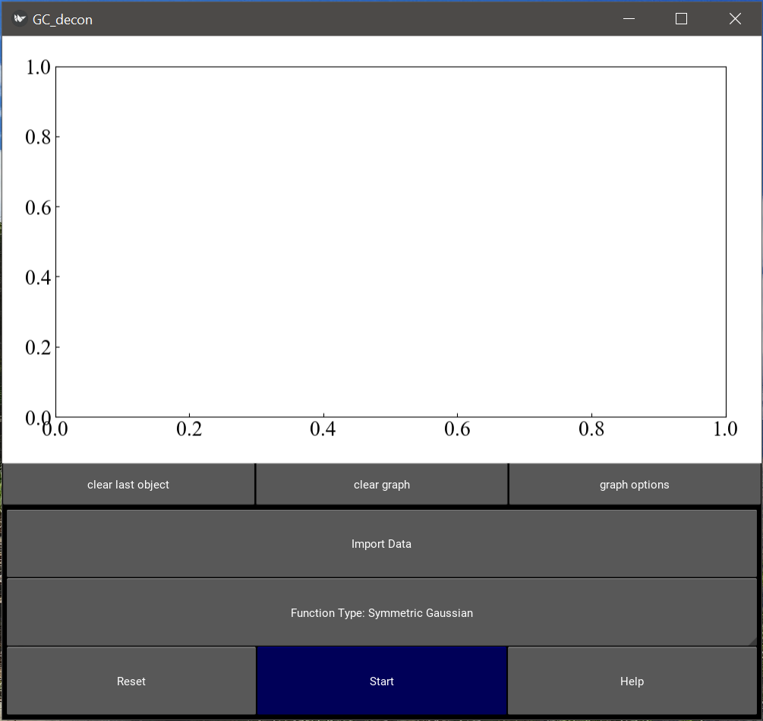

1. Using the opened file directory, navigate to the file location for the input data. Click on the data file (should read ‘.xlsx’, or ‘.csv’) and press ‘Select’.

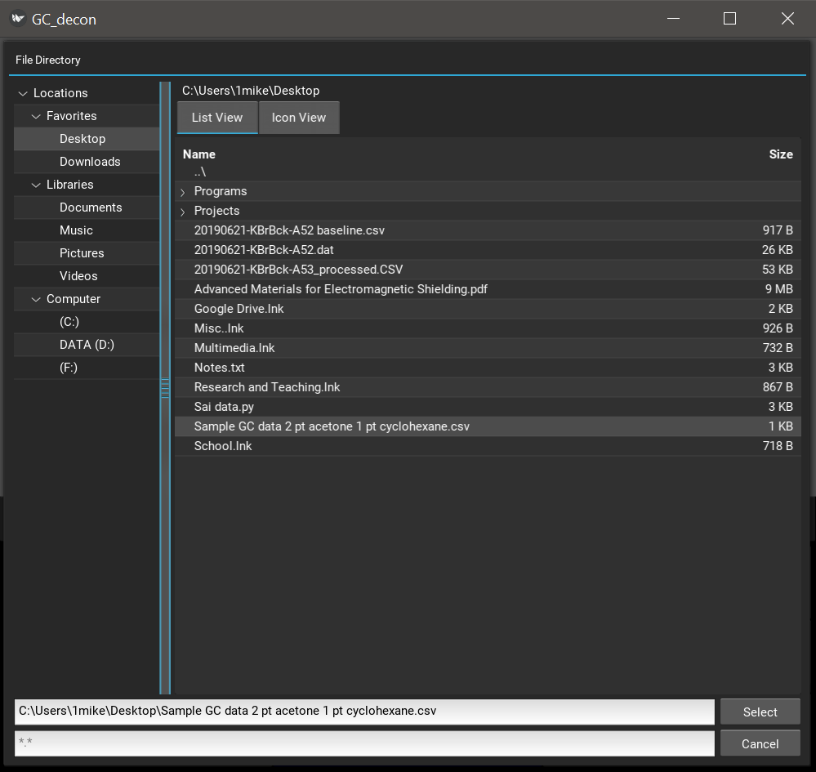

1. Once the data has been added to the graph, simply click the (x, y) points where you would like to 'guess' there is a gaussian distribution. The program will attempt to fit one gaussian distribution to the data set for each point which is picked on the graphing canvas. The points do not need to be selected perfectly, though there is a higher probability of finding the global minimum as your guess is made more accurate. Should you wish to delete any points, the button 'clear last object' will remove the most recently placed point from the graph. If you wish to start over from here, you can clear the graph entirely by selecting 'clear graph'. (if you accidentally do this, simply repress ‘import data’ and ‘select’ to add the data back to the screen).

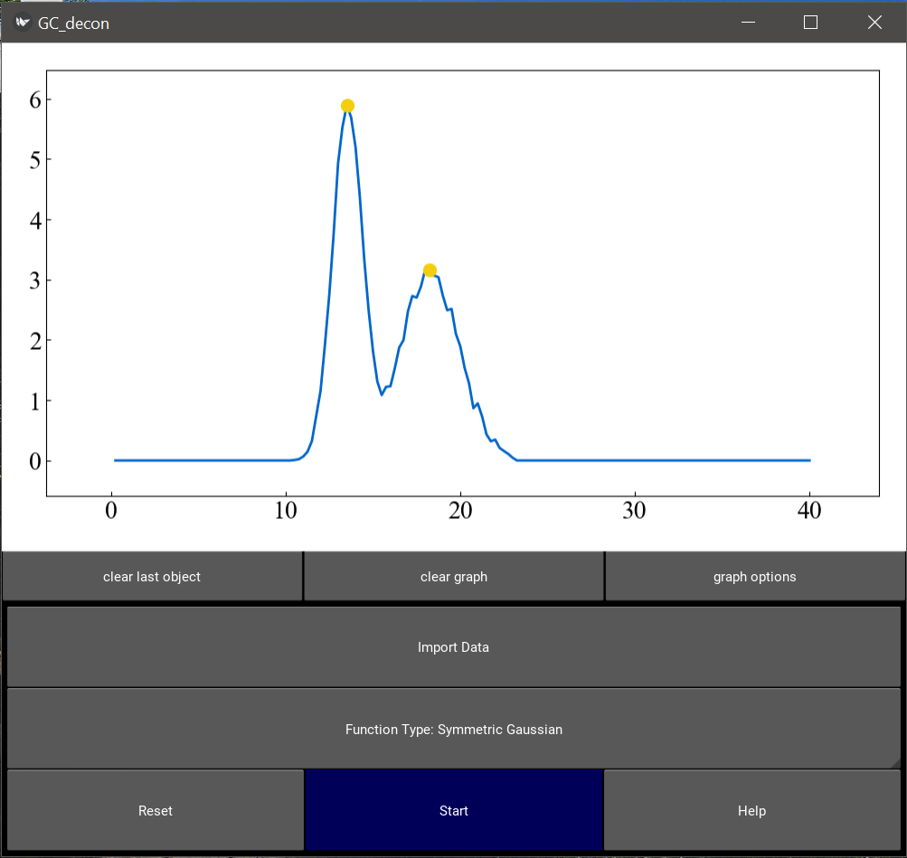

1. 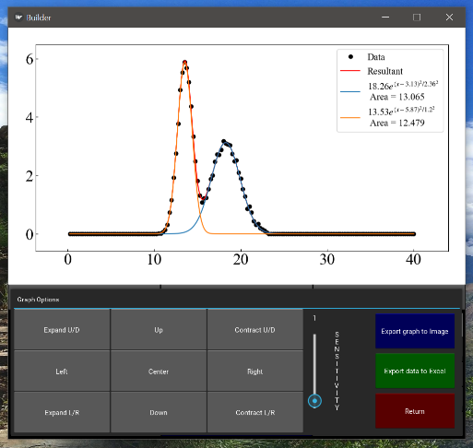Once the program is finished deconvoluting the data set, the graphing window will clear and display the results. This graph is customizable through the graphical properties available in the window, using the built-in buttons which move the plot Up/Down and Left/Right, as well as Expand/Contract along both axes. Adjusting the 'Sensitivity' slider adjusts the magnitude to which each button press adjusts the graph. The 'Center' button returns the graph to the space which the imported data occupies. Once the graph looks as desired, press the 'Export graph to Image' button to save the graph as a .png image in the file location of the input data on your computer. The user can also export the graph data to an excel file by pressing 'Export data to Excel'.